Side-attached composite solids

Definition
# Source: AI Source: Provided by: [Data Path: Persons Table -> ID Column: 1, Name_En Column: Motasem Essam] -> From: [ChatGPT] on [7/25/2026]
Side-Attached Composite Solids are composite three-dimensional objects formed by joining two or more solid components along one or more portions of their lateral surfaces (side surfaces), rather than connecting them only through their top or bottom bases or terminal faces.
The components may have the same or different shapes and dimensions. They can be attached along flat faces, curved surfaces, or partial side regions.
Simple Definition: Side-attached composite solids are solids formed when two or more three-dimensional shapes are connected through their sides.

Geometric Representation
# Source: AI Source: Provided by: [Data Path: Persons Table -> ID Column: 1, Name_En Column: Motasem Essam] -> From: [ChatGPT] on [7/25/2026]
A side-attached composite solid may contain components such as:
- Two rectangular prisms joined along lateral faces.
- A cylinder attached to the side of a rectangular prism.
- Two cylinders attached side-by-side.
- A cone attached to the lateral surface of another solid.
- Several different solids connected through side regions.
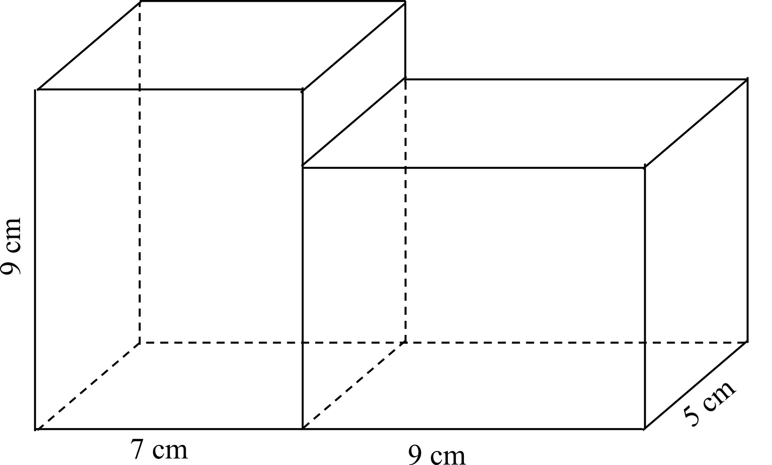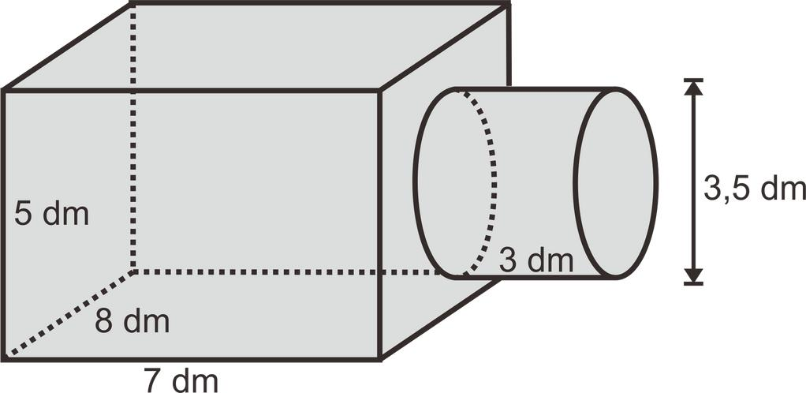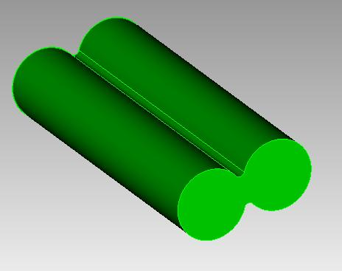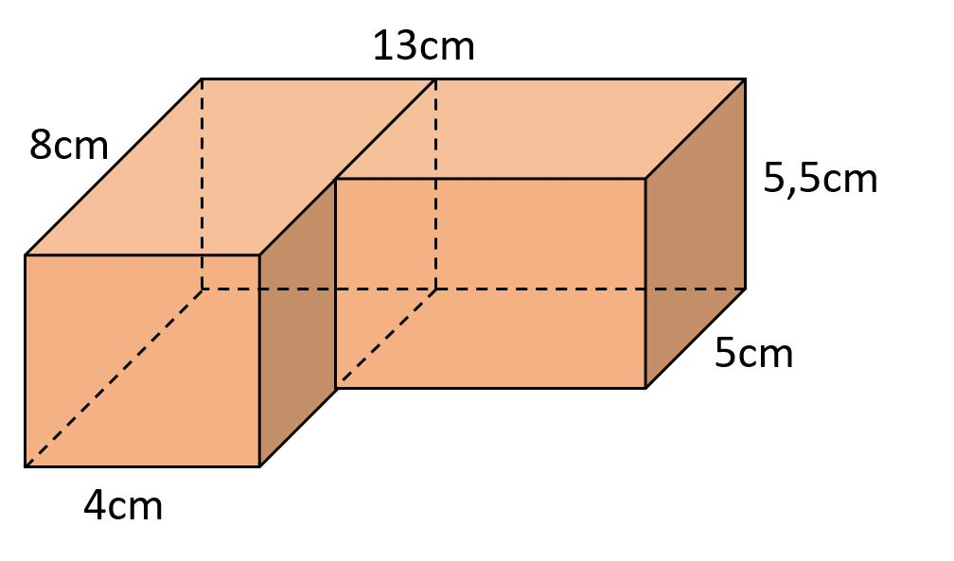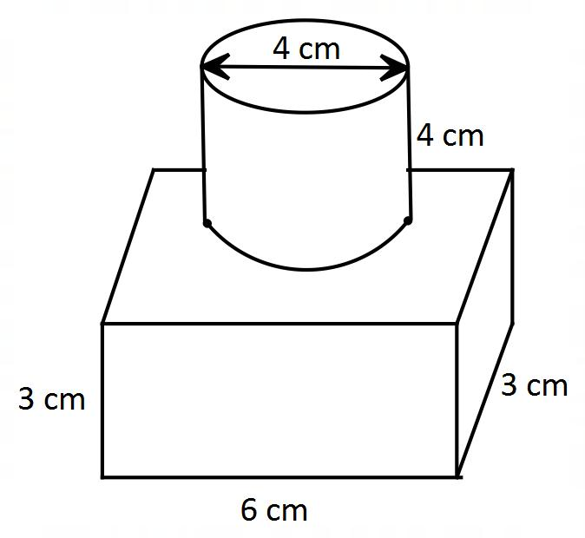

Main Classification
# Source: AI Source: Provided by: [Data Path: Persons Table -> ID Column: 1, Name_En Column: Motasem Essam] -> From: [ChatGPT] on [7/25/2026]
Side-attached composite solids can be classified according to the shapes of their components and the way their lateral surfaces are connected.

Types of Side-Attached Composite Solids
# Source: AI Source: Provided by: [Data Path: Persons Table -> ID Column: 1, Name_En Column: Motasem Essam] -> From: [ChatGPT] on [7/25/2026]

Prism-Based Side-Attached Composite Solids
# Source: AI Source: Provided by: [Data Path: Persons Table -> ID Column: 1, Name_En Column: Motasem Essam] -> From: [ChatGPT] on [7/25/2026]
Formed by attaching two or more prisms along portions of their lateral faces.
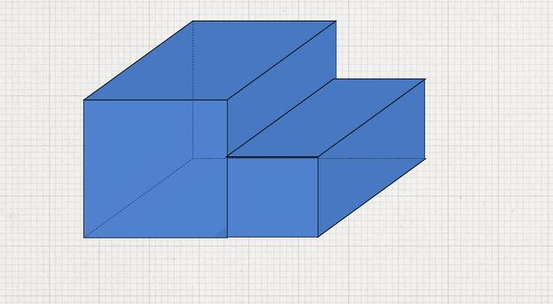

Cylinder-Based Side-Attached Composite Solids
# Source: AI Source: Provided by: [Data Path: Persons Table -> ID Column: 1, Name_En Column: Motasem Essam] -> From: [ChatGPT] on [7/25/2026]
Formed by attaching cylinders through portions of their curved lateral surfaces or other side regions.
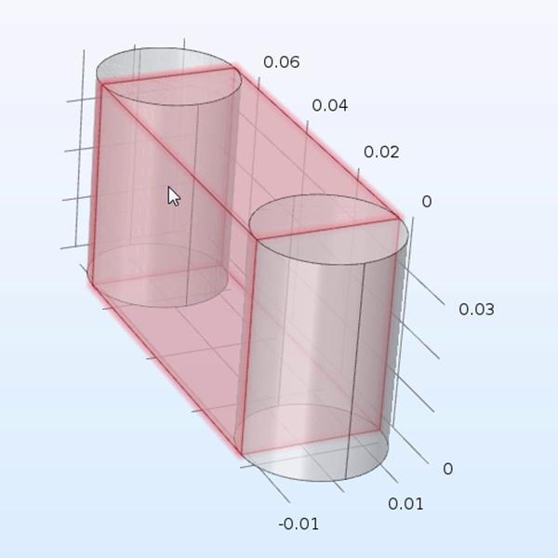

Cone-Based Side-Attached Composite Solids
# Source: AI Source: Provided by: [Data Path: Persons Table -> ID Column: 1, Name_En Column: Motasem Essam] -> From: [ChatGPT] on [7/25/2026]
Formed when cones are attached to other solids through portions of their lateral surfaces.
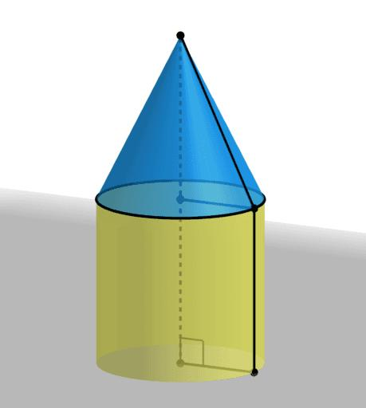

Pyramid-Based Side-Attached Composite Solids
# Source: AI Source: Provided by: [Data Path: Persons Table -> ID Column: 1, Name_En Column: Motasem Essam] -> From: [ChatGPT] on [7/25/2026]
Formed by joining pyramids or attaching pyramids to other solids through lateral triangular faces or portions of their sides.
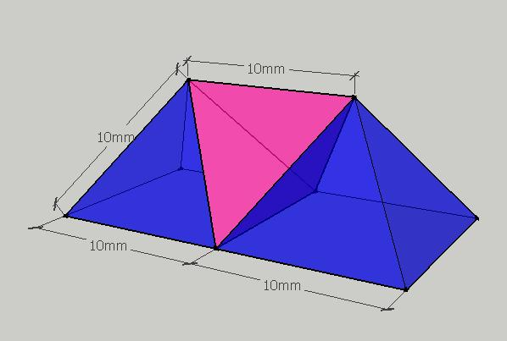

Sphere-Based Side-Attached Composite Solids
# Source: AI Source: Provided by: [Data Path: Persons Table -> ID Column: 1, Name_En Column: Motasem Essam] -> From: [ChatGPT] on [7/25/2026]
Formed by attaching spheres to other solids through contact regions on their curved surfaces.
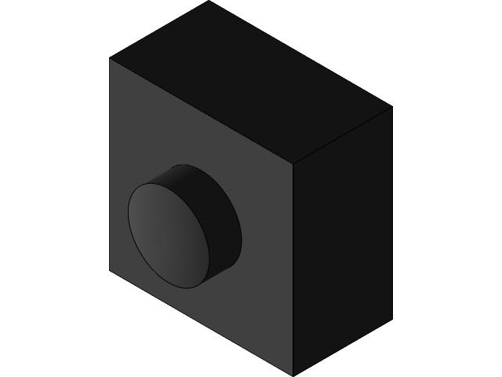

Mixed-Shape Side-Attached Composite Solids
# Source: AI Source: Provided by: [Data Path: Persons Table -> ID Column: 1, Name_En Column: Motasem Essam] -> From: [ChatGPT] on [7/25/2026]
Formed by joining different types of solids through their lateral or side regions.
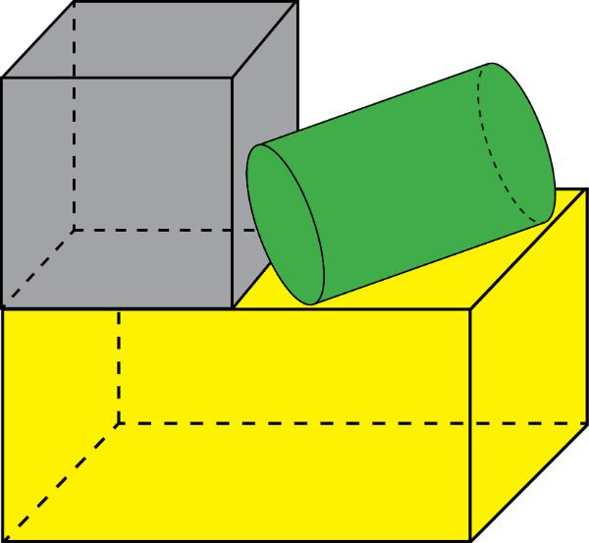

Classification by Attachment Arrangement
# Source: AI Source: Provided by: [Data Path: Persons Table -> ID Column: 1, Name_En Column: Motasem Essam] -> From: [ChatGPT] on [7/25/2026]
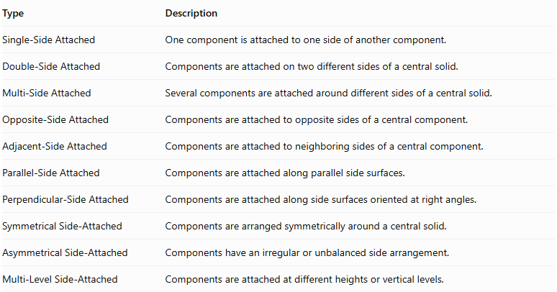
Type | Description
Single-Side Attached | One component is attached to one side of another component.
Double-Side Attached | Components are attached on two different sides of a central solid.
Multi-Side Attached | Several components are attached around different sides of a central solid.
Opposite-Side Attached | Components are attached to opposite sides of a central component.
Adjacent-Side Attached | Components are attached to neighboring sides of a central component.
Parallel-Side Attached | Components are attached along parallel side surfaces.
Perpendicular-Side Attached | Components are attached along side surfaces oriented at right angles.
Symmetrical Side-Attached | Components are arranged symmetrically around a central solid.
Asymmetrical Side-Attached | Components have an irregular or unbalanced side arrangement.
Multi-Level Side-Attached | Components are attached at different heights or vertical levels.
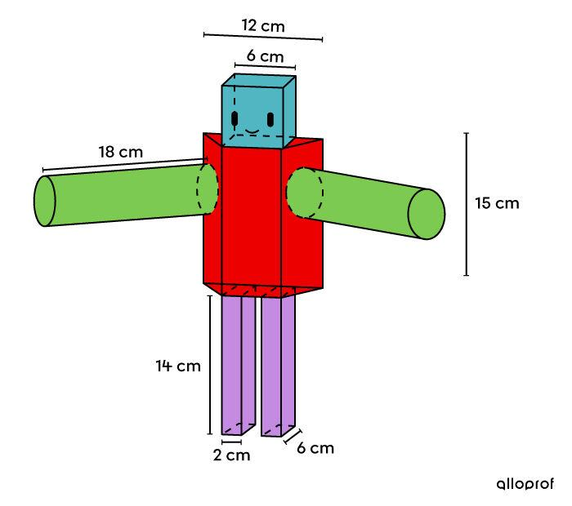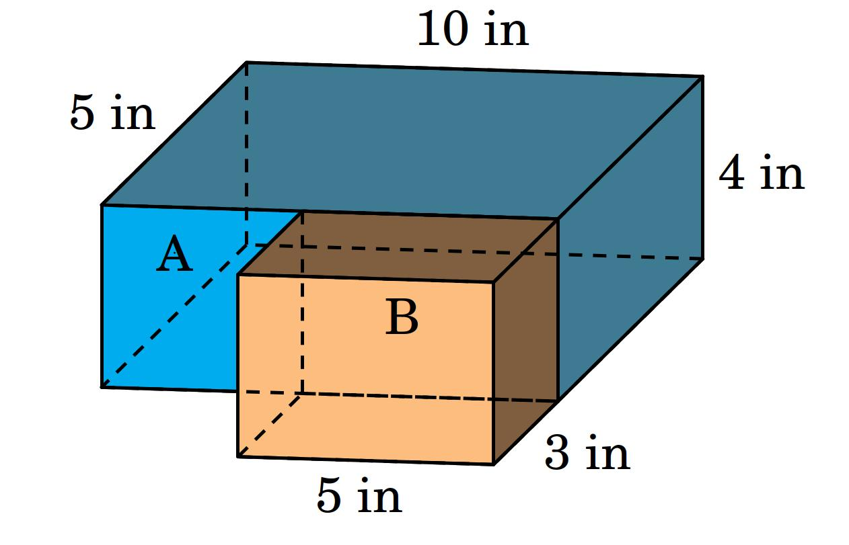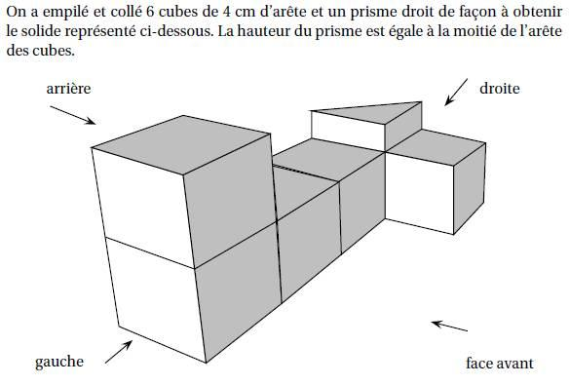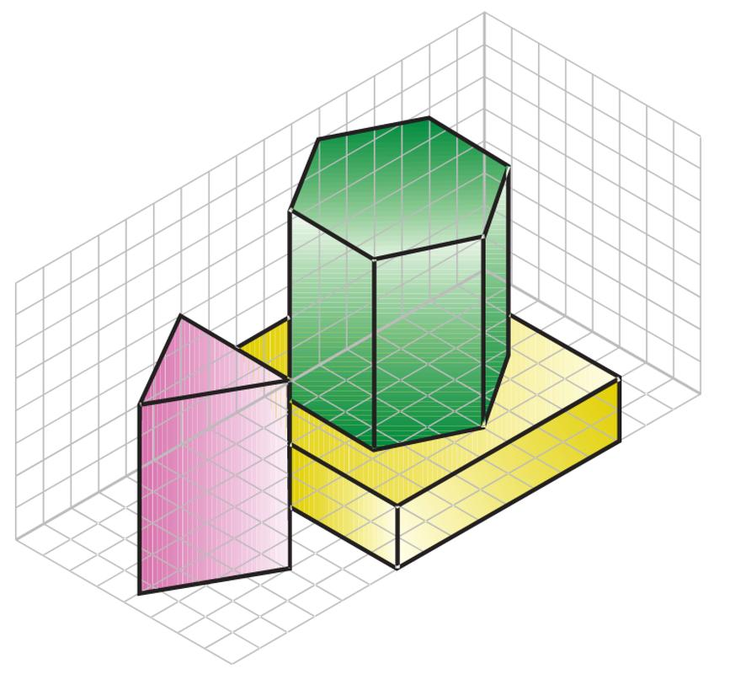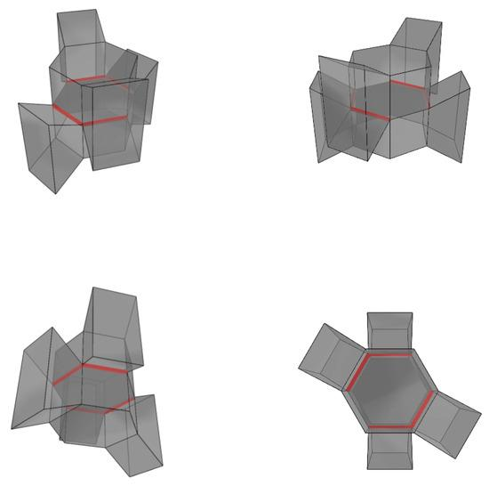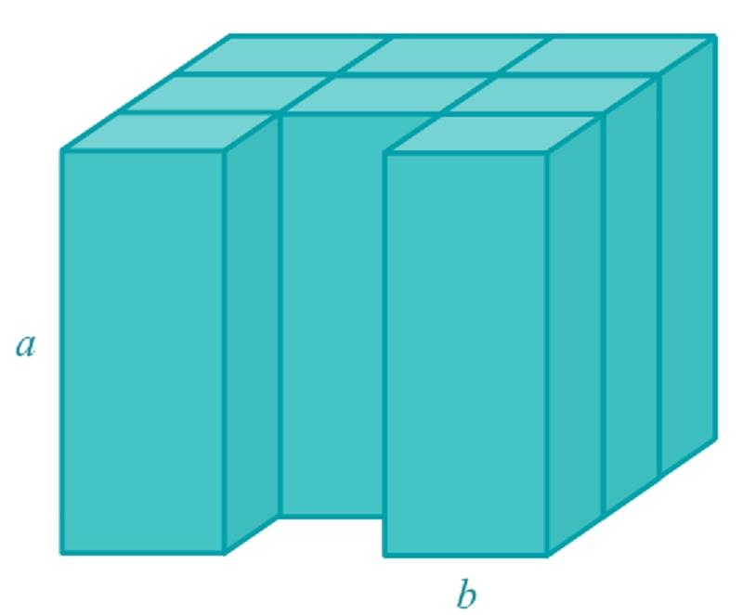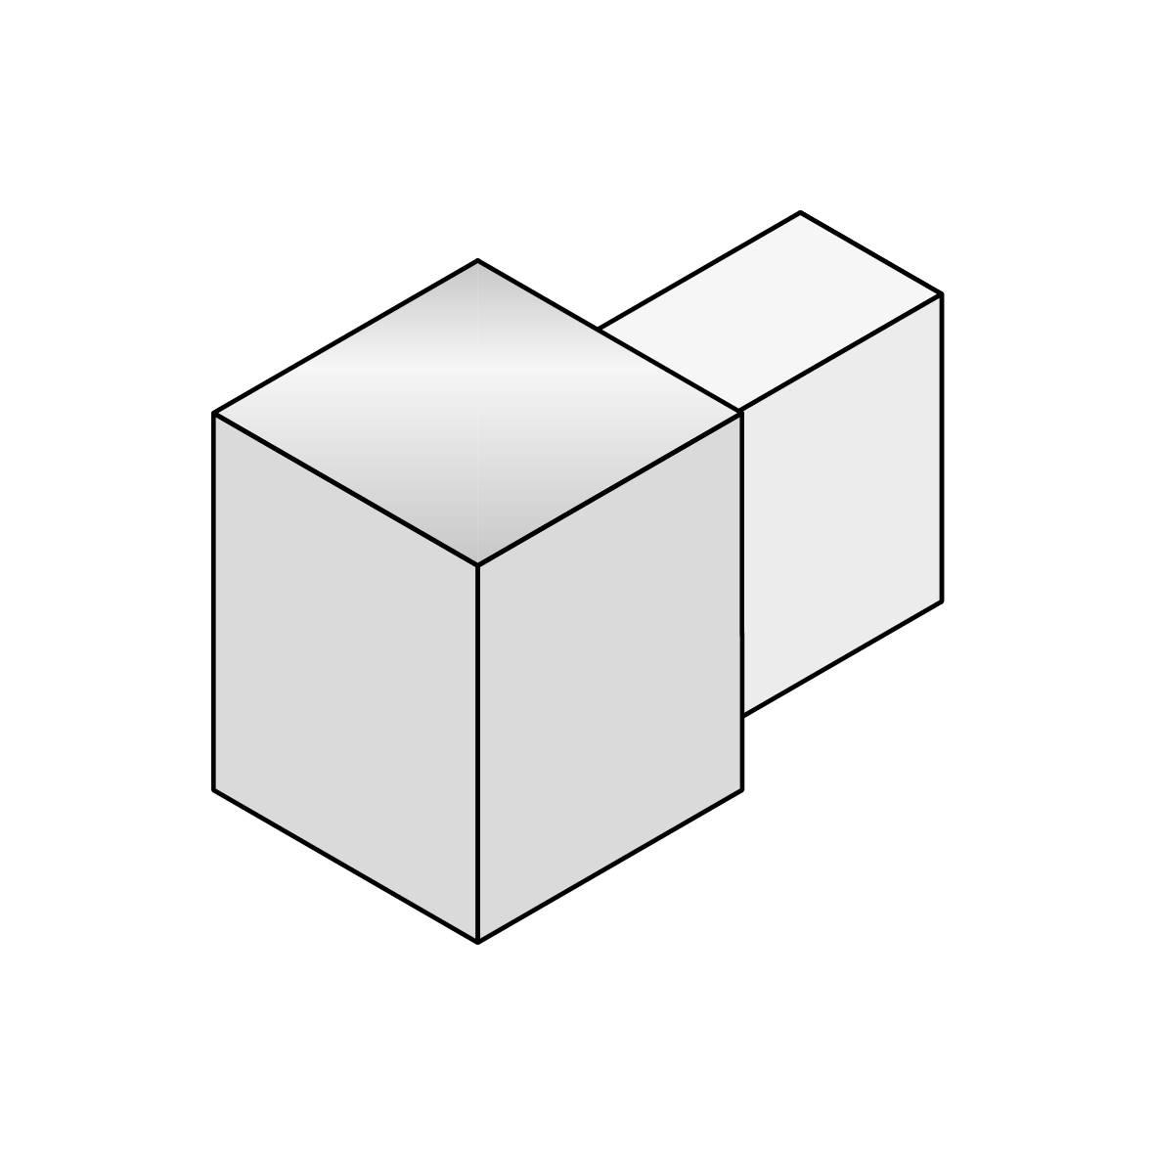

Classification by Attachment Surface
# Source: AI Source: Provided by: [Data Path: Persons Table -> ID Column: 1, Name_En Column: Motasem Essam] -> From: [ChatGPT] on [7/25/2026]
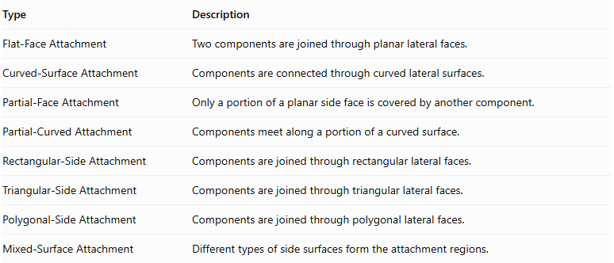
Type | Description
Flat-Face Attachment | Two components are joined through planar lateral faces.
Curved-Surface Attachment | Components are connected through curved lateral surfaces.
Partial-Face Attachment | Only a portion of a planar side face is covered by another component.
Partial-Curved Attachment | Components meet along a portion of a curved surface.
Rectangular-Side Attachment | Components are joined through rectangular lateral faces.
Triangular-Side Attachment | Components are joined through triangular lateral faces.
Polygonal-Side Attachment | Components are joined through polygonal lateral faces.
Mixed-Surface Attachment | Different types of side surfaces form the attachment regions.

Classification by Component Relationship
# Source: AI Source: Provided by: [Data Path: Persons Table -> ID Column: 1, Name_En Column: Motasem Essam] -> From: [ChatGPT] on [7/25/2026]
- Equal-Component Side Attachment: Components have identical shapes and dimensions.
- Unequal-Component Side Attachment: Components have the same shape but different dimensions.
- Mixed-Component Side Attachment: Components have different geometric shapes.
- Repeated Side Attachment: Multiple identical components are attached to the sides of a central solid.
- Nested Side Attachment: One component is positioned partly within another while also connecting through a side region, where the geometry permits it.

Mathematical Properties and Formulas
# Source: AI Source: Provided by: [Data Path: Persons Table -> ID Column: 1, Name_En Column: Motasem Essam] -> From: [ChatGPT] on [7/25/2026]
The mathematical properties depend on the shapes, dimensions, and attachment regions of the components.

Volume
# Source: AI Source: Provided by: [Data Path: Persons Table -> ID Column: 1, Name_En Column: Motasem Essam] -> From: [ChatGPT] on [7/25/2026]
For components joined without overlapping interiors:
$$V_{total}=V_{1}+V_{2}+⋯+V_{n}$$
If the components overlap internally:
$$V_{total}=\sum{V_{i}}-V_{overlap}$$
For multiple overlapping regions, the overlap correction must account for every region without double-counting.

Surface Area
# Source: AI Source: Provided by: [Data Path: Persons Table -> ID Column: 1, Name_En Column: Motasem Essam] -> From: [ChatGPT] on [7/25/2026]
The external surface area includes only surfaces exposed to the outside.
For two components joined through a complete matching planar side face:
$${SA}_{total}={SA}_{1}+{SA}_{2}-2A_{c}$$
Where:
- ${SA}_{1}$ = Surface area of the first component.
- ${SA}_{2}$ = Surface area of the second component.
- $A_{c}$ = Area of the shared contact face.
For partial planar attachment:
$${SA}_{total}={SA}_{1}+{SA}_{2}-2A_{c}$$
Here, $A_{c}$ represents only the actual hidden contact region, not the entire side face.
For curved or irregular attachment surfaces, calculate the exposed surface area directly using the actual geometry.

Overall Dimensions
# Source: AI Source: Provided by: [Data Path: Persons Table -> ID Column: 1, Name_En Column: Motasem Essam] -> From: [ChatGPT] on [7/25/2026]
The overall dimensions depend on the attachment direction and the dimensions of each component.
For two rectangular prisms attached side-by-side along matching side faces, their combined width may be:
$$W_{total}=W_{1}+W_{2}$$
This applies when the prisms are placed consecutively along the width direction without overlap.

Worked Examples

Example 1: Two Rectangular Prisms Attached Side-by-Side
# Source: AI Source: Provided by: [Data Path: Persons Table -> ID Column: 1, Name_En Column: Motasem Essam] -> From: [ChatGPT] on [7/25/2026]
Two identical rectangular prisms are attached through their lateral faces.
Each prism has:
- Length = 6 cm
- Width = 3 cm
- Height = 4 cm
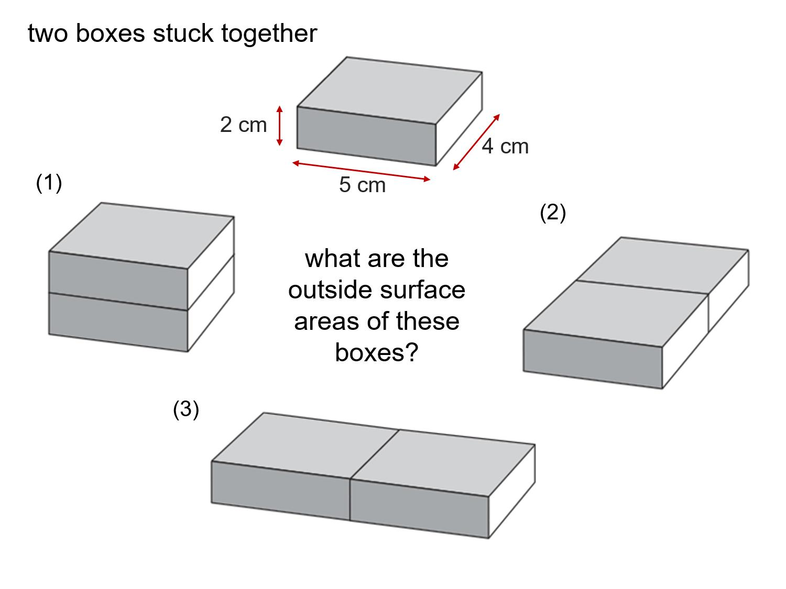
Step 1: Calculate the volume of one prism.
$$V_{1}=L×W×H$$
$$V_{1}=6×3×4=72$$
Step 2: Calculate the total volume.
$$V_{total}=72+72$$
$$\boxed{V_{total}=144{ cm}^{3}}$$
Step 3: Calculate the external surface area.
The surface area of one prism is:
$${SA}_{1}=2(LW+LH+WH)$$
$${SA}_{1}=2(18+24+12)=108$$
The shared lateral face has area:
$$A_{c}=3×4=12$$
Therefore:
$${SA}_{total}=108+108-2(12)$$
$$\boxed{{SA}_{total}=192{ cm}^{2}}$$
Step 4: Calculate the overall dimensions.
$$L_{total}=6+6=12 cm$$
The resulting solid is a rectangular prism measuring:
$$12×3×4 cm$$

Example 2: A Cylinder Attached to the Side of a Rectangular Prism
# Source: AI Source: Provided by: [Data Path: Persons Table -> ID Column: 1, Name_En Column: Motasem Essam] -> From: [ChatGPT] on [7/25/2026]
A cylinder is attached to the lateral face of a rectangular prism. Assume the cylinder's curved surface contacts the prism along a rectangular region, and the circular ends remain exposed.
- Rectangular prism: $8×6×5$ cm
- Cylinder radius: $1$ cm
- Cylinder height: $5$ cm
- Cylinder axis is parallel to the prism's height.
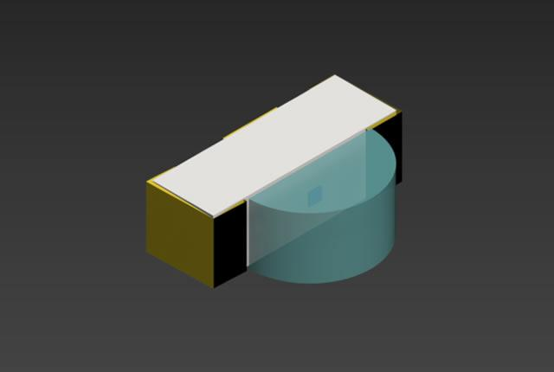
Step 1: Calculate the prism volume.
$$V_{p}=8×6×5=240$$
Step 2: Calculate the cylinder volume.
$$V_{c}=πr^{2}h$$
$$V_{c}=π(1)^{2}(5)=5π$$
Step 3: Calculate the total volume.
Assuming no overlap of the component interiors:
$$V_{total}=240+5π$$
$$\boxed{V_{total}≈255.71{ cm}^{3}}$$
Step 4: Calculate the external surface area.
The prism surface area is:
$${SA}_{p}=2(8×6+8×5+6×5)$$
$${SA}_{p}=236{ cm}^{2}$$
The cylinder surface area is:
$${SA}_{c}=2πr^{2}+2πrh$$
$${SA}_{c}=2π+10π=12π$$
The actual hidden contact region depends on how the cylinder is embedded in or attached to the prism. Therefore, the exact external surface area cannot be calculated from the dimensions alone; the attachment geometry must also be specified.

Important Characteristics
# Source: AI Source: Provided by: [Data Path: Persons Table -> ID Column: 1, Name_En Column: Motasem Essam] -> From: [ChatGPT] on [7/25/2026]
- They contain two or more connected solid components.
- Their components are joined through lateral or side regions.
- Components may have identical or different geometric shapes.
- Attachments can occur on one side, multiple sides, or opposite sides.
- Side-contact regions may be planar, curved, or partially covered.
- Their volume is calculated from the component volumes, with overlap corrections when necessary.
- Their external surface area excludes hidden contact regions.
- Their overall dimensions depend on the arrangement and attachment positions.

Comparison with Other Composite Solid Arrangements
# Source: AI Source: Provided by: [Data Path: Persons Table -> ID Column: 1, Name_En Column: Motasem Essam] -> From: [ChatGPT] on [7/25/2026]
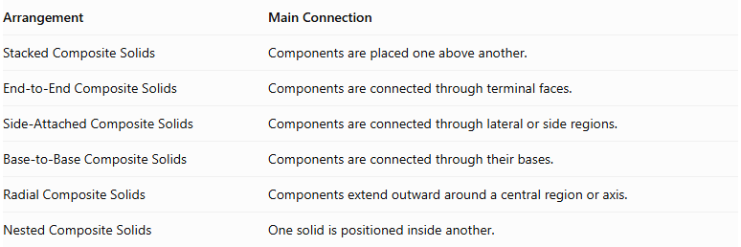
Arrangement | Main Connection
Stacked Composite Solids | Components are placed one above another.
End-to-End Composite Solids | Components are connected through terminal faces.
Side-Attached Composite Solids | Components are connected through lateral or side regions.
Base-to-Base Composite Solids | Components are connected through their bases.
Radial Composite Solids | Components extend outward around a central region or axis.
Nested Composite Solids | One solid is positioned inside another.

Applications
# Source: AI Source: Provided by: [Data Path: Persons Table -> ID Column: 1, Name_En Column: Motasem Essam] -> From: [ChatGPT] on [7/25/2026]
Side-attached composite solids can represent:
- Buildings with attached side extensions.
- Pipes and cylindrical conduits connected to structures.
- Mechanical assemblies with side-mounted components.
- Storage tanks with attached cylindrical sections.
- Architectural structures with projecting wings.
- Industrial equipment with attached housings.

Key Points
# Source: AI Source: Provided by: [Data Path: Persons Table -> ID Column: 1, Name_En Column: Motasem Essam] -> From: [ChatGPT] on [7/25/2026]
- Side-attached composite solids are formed by connecting solids through their lateral surfaces or side regions.
- They may contain prisms, cylinders, cones, pyramids, spheres, or mixed shapes.
- Attachments can be single-sided, double-sided, opposite-sided, or multi-sided.
- The volume is the sum of component volumes when their interiors do not overlap.
- Surface area must exclude all hidden contact regions.
- Curved-surface attachments require careful geometric analysis.

Conclusion
# Source: AI Source: Provided by: [Data Path: Persons Table -> ID Column: 1, Name_En Column: Motasem Essam] -> From: [ChatGPT] on [7/25/2026]
Side-Attached Composite Solids are three-dimensional structures formed by connecting two or more solids through their side surfaces rather than only through their bases or terminal faces. They can have flat, curved, or partial contact regions and may involve identical or different solid shapes. Their classification depends on component types, attachment arrangements, and contact surfaces. Understanding these arrangements is essential for calculating their combined volume, external surface area, and overall dimensions.

